1. **Bond number or Eötvös number** 
   1. Used to determine stability of helium-propellant interfaces and how and where the propellant will be in the lines
   2. 1. – absolute value of the difference in density between the gaseous and liquid species
      2. $a$– acceleration vector normal to surface of the liquid on the liquid-gaseous interface
      3. $L$– characteristic length (diameter in a pipe)
      4. $γ$– surface tension of the liquid
   3. It makes sense that the higher the surface tension, the lower the bond number, and the more likely the interface is to remain stable
2. **Contact angle**
   1. Used to determine wettability of a liquid
   2. Larger the contact angle, the worse the wetting
   3. Important for understanding how liquids stick to surfaces

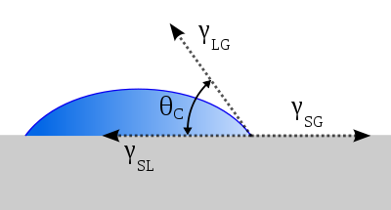

1. **Bulk modulus ( *K* ) and effective bulk modulus**
   1. Used to relate the change in volume or density of a liquid–or fluid, or liquid-vapor mixture–to the change in pressure. The higher the bulk modulus, the more pressure is needed for a given change in volume of the liquid, the less compliant the species.
   2. 1. – bulk modulus [Pa or psi]
      2. $V$– volume of the fluid
      3. $P$– pressure
   3. Effective bulk modulus: $\frac{1}{K_{eff}}= \frac{1}{K_{fluid,1}}+ \frac{1}{K_{fluid,2}}+…$
      1. The compliance of a wall can also be lumped into this effective bulk modulus
   4. Can superimpose the change in density from a pressure change with the fact that the density cannot change to backout the temperature change required for negation! This can be done using ideal relations, tabular lookup, or a software like refprop. The example derivation below uses ideal gas relations:
 $dρ= ρ\frac{ dP}{K}$

 $ρ= -dρ+\frac{P_{2}}{RT_{2}}= \frac{P_{1}}{RT_{1}}$

 $ρ= -\left(ρ\frac{ dP}{K}\right)+\frac{P_{2}}{RT_{2}}= \frac{P_{1}}{RT_{1}}$

 $T_{2}=\frac{P_{2}}{R\left(\frac{P_{1}}{RT_{1}}+\left(ρ\frac{ dP}{K}\right)\right)}$

  1. Assuming both pressure states are known, then since the density must remain constant, we can obtain the temperature that would be required for this density to remain the same
      2. This equation tells that generally, the less compliant the liquid (higher bulk modulus), the higher the temperature change under a given pressure change needed to maintain a fixed density fluid (hydrolocked liquid)
2. **K-factors or loss coefficients and Darcy friction factors**
   1. K-factors, or loss coefficients, are Darcy friction factors that have been scaled by the length and diameter of the pipe/fitting in question to remove dependency on the length and diameter of the pipe for calculating pressure head loss.
   2. Darcy–Weisbach friction factor:
      * 1. – diameter of tube
        2. $l$– length of the tube
        3. ${∆P}_{T}$– change in total pressure from the beginning of tube to end of tube along the longitudinal dimension, *l*. If the flow is fully developed and has negligible changes in density across this fitting, this is equal to the change in static pressure as dynamic pressure is constant.
        4. $u$– bulk average speed of fluid through tube
        5. $ρ$– average density of the fluid in tube
      1. Relation to shear stress:
         1. Assume fully developed flow in the longitudinal direction of a pipe (no dependency of speed on distance in that direction)
         2. Momentum balance on control volume of fluid inside that longitudinal section gives us:
 $\frac{{∆P}_{T}πd^{2}}{4}= τ_{wall}πdl= F_{f}$

 $\left(\frac{\frac{1}{2}fρu^{2}l}{d}\right)\frac{πd^{2}}{4}= τ_{wall}πdl$

 $f=\frac{8τ_{wall}}{ρu^{2}}$

   2. Relation to frictional force on the flow of liquid
 $f=\frac{8τ_{wall}}{ρu^{2}}\frac{πdl}{πdl}$

 $f=8\frac{F_{f}}{ρu^{2}}\frac{1}{πdl}$

    3. So to review: $f\sim F_{f}\sim τ_{wall}\sim {∆P}_{T}$
      4. $f$ is a function of Reynolds Number and relative surface roughness; and the length and diameter of the pipe are needed to scale this factor to a frictional force. This dependency on Reynolds Number and relative roughness is shown below:

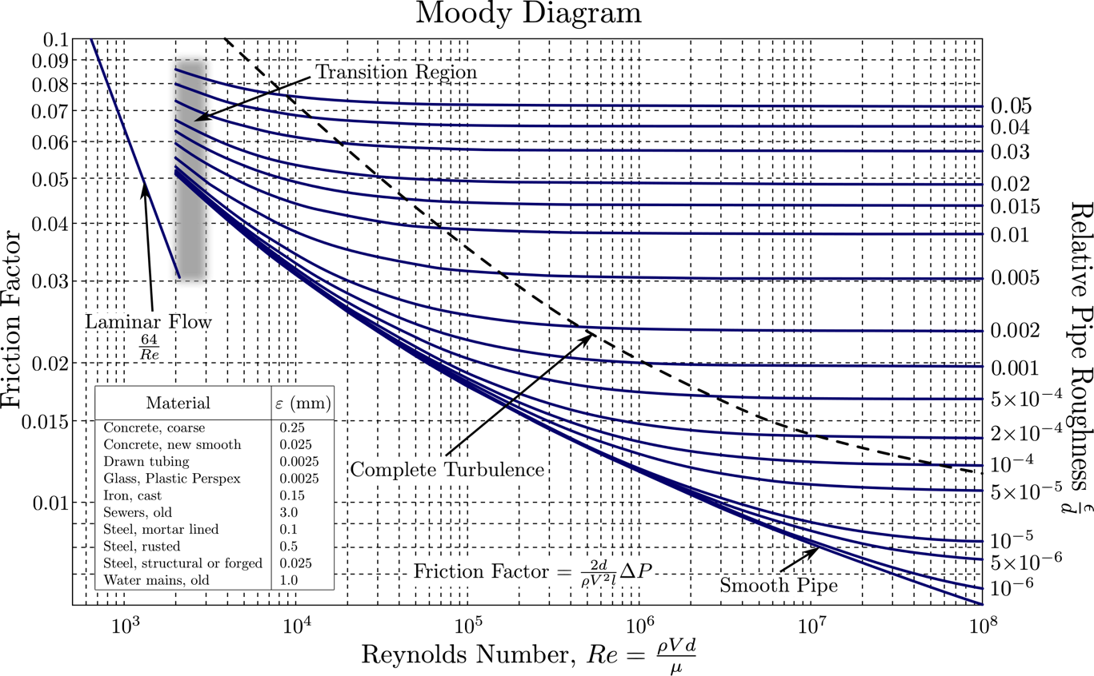

* 1. K-factor or loss coefficient
     1. Gives the loss over a particular fitting without dependency on length, diameter, or surface roughness (because these have been taken into account)
     2. Normally assumes a high Reynolds Number flow, thus, there is no further dependency on the flow speed for the calculation, and the surface roughness and the pipe geometry are all that is needed–or can specify nominal flow rates
 $K=f\frac{l}{d}$

 $K= \frac{ {∆P}_{T}}{\frac{1}{2}ρu^{2}}$

 ${∆P}_{T}= K\frac{1}{2}ρu^{2}={KP}_{d}$  3. – the change in total pressure is equal to the K-factor multiplied by the dynamic pressure **referenced to a particular flow area**. This reference point matters because it affects the dynamic pressure of the flow, so the K-factor has to be specified to that reference value. Think of the K-factor as “the number of dynamic pressure multiples we’re losing across a fitting in total pressure”
  2. Head loss:
     1. Gives the pressure lost over a particular fitting or length of pipe in terms of the height of a fluid column of that same fluid under the same density in Earth gravity
 ${∆P}_{T}= ρgh_{f}$

 $h_{f}=K\frac{\frac{1}{2}u^{2}}{g}$

 $h_{f}=f\frac{\frac{1}{2}u^{2}}{g}\frac{l}{d}$

  2. **Again please note the $∆P$**  term applies to total pressure
  3. Good resource for summarizing: [KB Engineering](http://kb.eng-software.com/display/ESKB/Relationship+Between+Flow+Coefficient+and+Resistance+Coefficient)

1. **Cd/Kd – discharge coefficient – based on the contracted geometric area flow sees**
 $Cd=Kd≡\frac{actual flow rate}{ideal flow rate}$

 $0 ≤Cd ≤1$

 1. Thin walled orifice $Cd=0.61$
   2. Venturi $Cd=0.995$
2. $R$**– recovery factor, the ability of flow to regain pressure after being accelerated through a fitting**
   * 1. Liquid or gas recovery factor, depending
     2. $P_{U}$– the upstream pressure
     3. $P_{D}$– the downstream total pressure
     4. $P_{th}$– static pressure at the throat
     5. $R≤1$**–** because the pressure change across the fitting is always less than or equal to the steep drop to low static pressure in the throat
     6. If $R=1$ the flow is very isentropic, pressure is regained
     7. If $R=0$ the flow is very entropic, pressure is not regained
     8. **High recovery in pressure is typified by a high recovery factor value**
     9. Venturis have recovery close to 0.97
3. **Cd*A – area that the fluid *sees* as it transverses a fitting, used for mass flow rates**
   1. Is not used to obtain pressure drops across fitting, it is only used to calculate the minimum area of the flow to derive flow rates and the choking area for flow that chokes
   2. Assuming fully *non-recovered* flow, the Cd*A term can be used to derive the mass flow rate through a fitting that is accurate and represents the pressure variation across said fitting
   3. This is because the Cd*A term is blind to all variations in properties downstream of the area

$\dot{m}=\left(Cd*A\right)ρu$

$\dot{m}=\left(Cd*A\right)\frac{P}{RT}Ma= \left(Cd*A\right)\frac{P}{RT}M\sqrt{γR_{gas}T}= \left(Cd*A\right)PM\sqrt{\frac{γ}{R_{gas}T} }$ (for compressible flow)

* + 1. – Mach number of the flow
    2. $P$– static pressure of flow at evaluated point
    3. $T$– static temperature of flow at evaluated point
    4. $R_{gas}$– specific gas constant
  1. $\dot{m}=\left(Cd*A\right)\sqrt{2ρ∆P_{T,U-th}}$ (for incompressible flow, derived from Bernoulli)
  2. $\dot{m}=\left(Cd*A\right)\sqrt{2ρ∆P_{U-th}}$ (for incompressible flow with low upstream speed)
     1. $∆P_{T,U-th}$– the change from upstream total pressure to static pressure at the throat
     2. $∆P_{U-th}$– the change in static pressure upstream to static pressure at throat
  3. The pressure that can be derived from the Cd*A, given the initial pressure is the static pressure at the throat
  4. If there is low recovery, **then we can stop here and say downstream pressure is equal to the pressure at the throat; but if there is any recovery–which there usually is–then to get the downstream pressure, we must use effective flow area, $A_{eff}$**

1. $A_{eff}$**or CdA – effective flow area**
   1. The flow area through a valve or fitting that would result in the upstream-to-downstream pressure total variation seen by flow through that particular fitting
   2. It is different from the geometric flow area multiplied by the discharge coefficient, which just takes into account the physical minimum area that the fluid occupies when passing through a fitting or tube
   3. This is used to get the change in pressure across the entire fitting, not just up to the throat, but it is **not representative of an actual area**
 $A_{eff}≡\frac{A*Cd}{\sqrt{1-R}}=\frac{A*Cd}{\sqrt{1- \frac{\left(P_{T,D}-P_{th}\right)}{\left(P_{T,U}-P_{th}\right)}}}$

     1. If $R=0$, then $A_{eff}=A*Cd$, no recovery in pressure, static pressure throat is equal to total pressure downstream of throat
      2. $A$– geometric area of the fitting
      3. $Cd$**–** is the discharge coefficient
      4. $R$–is the recovery of the fitting or valve
   4. It is used to relate the changes in upstream total pressure to downstream total pressure across a valve or fitting
 $\dot{m}=\left(Cd*A\right)\sqrt{2ρ∆P_{T,U-th}}= A_{eff}\sqrt{\left(1- \frac{\left(P_{T,D}-P_{th}\right)}{\left(P_{T,U}-P_{th}\right)}\right)2ρ∆P_{T,U-th}}$

 $∆P_{T,U-th}= P_{T,U}-P_{th}$

 $\dot{m}= A_{eff}\sqrt{\left(∆P_{T,U-th}- \left(P_{T,D}-P_{th}\right)\right)2ρ}= A_{eff}\sqrt{\left(P_{T,U}-P_{T,D}\right)2ρ}$

 $\dot{m}=A_{eff}\sqrt{2ρ{∆P}_{T}}$

 ${∆P}_{T}$ 1. – the change in total pressure across the fitting
      2. **For fittings with a low recovery, the effective area would not be needed, i.e. A*Cd giving us $∆P_{U-th}$ would have been sufficient**
   5. To make things more confusing, this is also sometimes called CdA, but it is not representative of a real discharge coefficient value, because if it were, then we would have Cd’s with values greater than 1! **But this area A is the reference area of the flow (the thing that limits the mass flow rate, which is A*Cd). Thus we have the confusing truth that CdA = Cd*(A*Cd), where the LHS is the effective area, the first Cd is not the discharge coefficient, but a pressure loss factor, and then the inner A*Cd is the reference flow area**.
   6. Connection to K-factor:

 $K= \frac{ {∆P}_{T}}{\frac{1}{2}ρu^{2}}$

 ${∆P}_{T}=K\frac{1}{2}ρu^{2}$

 $A_{eff}=CdA= \frac{\dot{m}}{\sqrt{2ρ{∆P}_{T}}}= \frac{ρUA}{\sqrt{2ρ\left(K\frac{1}{2}ρu^{2}\right)}}=\frac{A}{\sqrt{K}}$

 $Cd$  2. = $\frac{1}{\sqrt{K}}$
         1. $A$– is the reference flow area, in fact, it is actually equal to A*Cd when A is the geometric flow area and Cd is the discharge coefficient
         2. $Cd$– here is not discharge coefficient, but the inverse of the square root of the K-factor, and thus, can and often is greater than one!
2. **ESEOD – equivalent square edged orifice diameter**
   1. A way of sizing the flow area of an orifice to match the pressure loss/resistance across a fitting or pipe (usually one that is not actually circular) with a
   2. $Cd=0.65$ for ESEOD calculations
$A_{eff}=Cd*\left(\frac{π ESEOD^{2}}{4}\right)=0.65*\left(\frac{π ESEOD^{2}}{4}\right)$

3. **Cv – flow coefficient**
   1. Typically associated with the hydraulic performance of a control valve; other devices such as relief valves are characterized by the discharge coefficient (Cd)
 $Cv=Q*\sqrt{\frac{\left(ρ_{fl} / ρ_{H2O} \right)}{dP}}$

 $Q$    1. – volumetric flow rate (gpm)
      2. $dP$**–** total pressure drop across the valve
      3. $ρ_{fl}$– density of fluid in question
      4. $ρ_{H2O}$– density of water
   2. Cv can be converted to Cd values using the commonality of their flow area term
   3. $Cv=38A*Cd$**for liquids**
   4. $Cv=27.66A*Cd$**for vapors and compressible gases**
4. **Conservation equations (1-D, inviscid, steady flow)**
   1. **Conservation of Mass**
      1. **Differential:**
 $\frac{d}{dx}\left(ρuA\right)=0$

     2. **Control Volume:**
 $ρ_{1}u_{1}A_{1}= ρ_{2}u_{2}A_{2}$

  2. **Conservation of Momentum**
      1. **Differential:**
 $\frac{dp}{dx}+ ρu\frac{du}{dx} =0$

        1. The differential form of momentum conservation, with unsteady and viscous terms added are what form the basis of the Navier-Stokes equations.
         2. Please **note**, the second term is called a convective term, as it results in the *convection* of momentum in a control volume
      2. **Control Volume (integrand of the integral form) :**
 $\int_{1}^{2}{A\left[\frac{dp}{dx}+ρu\frac{du}{dx}\right]dx} =A\int_{1}^{2}{\left[0\right]dx}$

 ${\left[pA\right]}_{2}-{[pA]}_{1}+ {[\dot{mA}]}_{2}- {[\dot{mA}]}_{1} =0$

 $p_{1}+ ρ_{1}u_{1}^{2}= p_{2}+ ρ_{2}u_{2}^{2}$      1. (simplified if the areas of the elements are taken to be equal, like a control volume. Note, however, that even if areas are equal, pressure variations will occur as more or less momentum is fluxed into the body)
   3. **Conservation of Energy**
      1. **Differential:**
 $\frac{dh}{dx}+ u\frac{du}{dx} =0$

     2. **Control Volume:**
 $h_{1}+\frac{u_{1}^{2}}{2}= h_{2}+\frac{u_{2}^{2}}{2}$

        1. The enthalpy terms take into account both the energy of the species and the p-dv work needed to compress or expand the fluids to their current states
      3. All the isentropic relation equations for compressible flows are derived from conservation of energy. Additionally, Bernoulli can be derived from conservation of energy if the